**STRUCTURE OF THE US BANKING SYSTEM**

The US banking system is a complex network comprising various types of financial institutions, regulatory bodies, and banking markets.

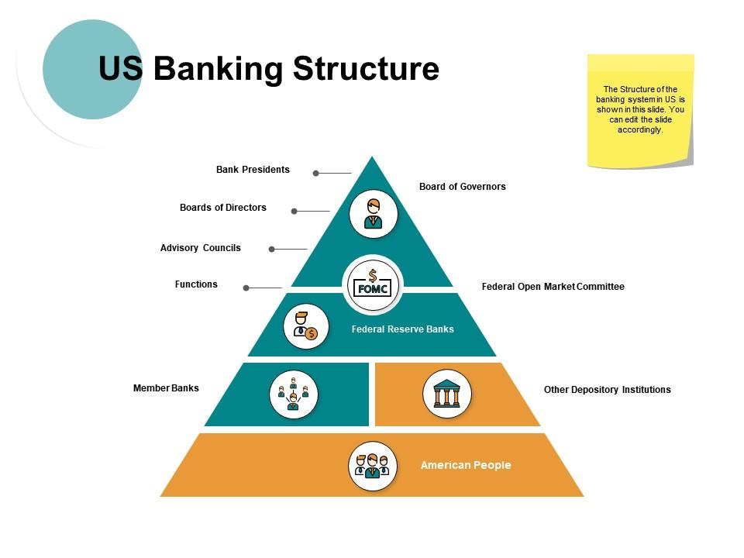

**Financial Institutions**

1. **Commercial Banks**

* **Description**: Offer a full range of services including deposits, loans, and checking accounts.
* **Number of Institutions**: Approximately 4,500 as of 2023.
* **Assets**: Over $23 trillion.

1. **Savings and Loan Associations (Thrifts)**

* **Description**: Specialize in accepting savings deposits and making mortgage loans.
* **Number of Institutions**: Around 700.
* **Assets**: Approximately $1 trillion.

1. **Credit Unions**

* **Description**: Member-owned financial cooperatives providing traditional banking services.
* **Number of Institutions**: About 5,100.
* **Assets**: Roughly $2 trillion.

1. **Investment Banks**

* **Description**: Specialize in large and complex financial transactions, including underwriting, acting as an intermediary between an issuer of securities and the investing public, facilitating mergers and other corporate reorganizations, and acting as a broker or financial advisor for institutional clients.
* **Major Players**: Goldman Sachs, Morgan Stanley, etc.

1. **Regional and Community Banks**

* **Description**: Smaller banks that serve local or regional areas.
* **Number of Institutions**: Estimated at 4,000.
* **Assets**: Varies widely, with many having less than $10 billion in assets.

**Regulatory Bodies**

* 1. **Federal Reserve System (The Fed)**
* **Role**: Central Bank of the United States, responsible for monetary policy, regulating banks, maintaining financial stability, and providing banking services.
* **Structure**: Board of Governors, 12 regional Federal Reserve Banks.

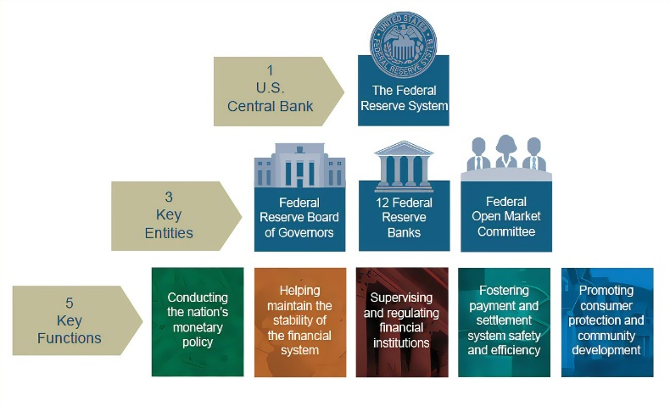

* 1. **Office of the Comptroller of the Currency (OCC)**
* **Role**: Regulates and supervises national banks and federal savings associations.
  1. **Federal Deposit Insurance Corporation (FDIC)**
* **Role**: Insures deposits at banks and thrifts, and supervises financial institutions for safety and soundness.
* **Insurance Coverage**: Up to $250,000 per depositor, per insured bank.
  1. **National Credit Union Administration (NCUA)**
* **Role**: Regulates and supervises federal credit unions.
* **Insurance Coverage**: Similar to the FDIC, up to $250,000 per depositor.

**Banking Markets**

1. **Retail Banking**

* **Services**: Personal banking services including savings and checking accounts, personal loans, mortgages, credit cards.
* **Major Players**: JPMorgan Chase, Bank of America, Wells Fargo.

1. **Commercial Banking**

* **Services**: Banking services for businesses including loans, credit, savings accounts, and treasury services.
* **Major Players**: Citibank, Bank of America, Wells Fargo.

1. **Investment Banking**

* **Services**: Advisory services for mergers and acquisitions, underwriting, trading of securities, and market-making.
* **Major Players**: Goldman Sachs, Morgan Stanley.

|  |  |
| --- | --- |
| **Commercial Banks** | $23 trillion |
| **Credit Unions** | $2 trillion |
| **Savings Institutions** | $1 trillion |

**Total Assets in the Banking System**

|  |  |
| --- | --- |
| **Commercial Banks** | 4500 |
| **Credit Unions** | 5100 |
| **Savings and Loan Associations** | 700 |

**Number of Institutions**

**Deposit Insurance Coverage**

* **FDIC and NCUA**: Up to $250,000 per depositor, per insured bank/credit union

**Market Concentration**

* The top five banks (JPMorgan Chase, Bank of America, Citibank, Wells Fargo, U.S. Bank) hold nearly **50%** of the total banking assets in the U.S.

**The US Banking System is Large, Diverse, and Complex**

* Four federal-level bank supervisors
* Fifty state-level bank supervisors
* Nearly 9,000 FDIC-insured banks
* $11.5 trillion in banking assets
* $4 trillion in FDIC-insured deposits
* Three largest banks have $3.5 trillion in assets
* Biggest bank: >$1.1 trillion in assets
* Smallest bank: <$3 million in assets
* 8,138 community banks with total assets <$1 billion
* Median bank size about $140 million

**structure change of us banking from traditional banking from now**

The structure of the US banking system has undergone significant changes over the years, driven by advancements in information technology (IT), deregulation, and changes in monetary policy. Here are some key points summarizing the evolution of the US banking system:

**1. Increased Competition:** The rise of FinTech companies and online-only banks has increased competition for traditional banks, forcing them to adapt and invest in digital technology to remain competitive.

**2. Digital Banking:** The shift towards digital banking has made banking services more accessible and convenient, with customers able to access their accounts and perform transactions online and through mobile apps.

**3. Consolidation:** The banking industry has consolidated over the years, with fewer but larger institutions emerging. This consolidation has led to a more efficient industry with lower costs and improved risk management.

**4. Changes in Balance Sheet Composition:** The composition of commercial banks' balance sheets has changed over time, with a shift towards more liquid assets and a reduction in the proportion of loans to total asset.

**5. Impact of Monetary Policy:** Changes in monetary policy have affected banks' net interest income (NII), with interest rate shocks and quantitative tightening influencing the profitability of banks.

**6. Increased Focus on Risk Management:** Banks have become more focused on managing their risk exposure, particularly interest rate risk, through the use of derivatives and other hedging instruments.

**7. Changes in Deposit Structure:** The structure of deposits has changed, with a shift towards more variable-rate and short-term deposits, which are more sensitive to changes in interest rates.

**8. Increased Use of Technology:** Banks have increasingly used technology to manage their risk exposure, improve operational efficiency, and enhance customer experience.

**9. Changes in Regulatory Environment:** The regulatory environment has changed, with the introduction of new regulations and guidelines aimed at improving the stability and resilience of the banking system.

**10. Impact on Financial Inclusion:** The shift towards digital banking has contributed to financial inclusion by providing accessibility to remote areas and unbanked populations, but addressing the digital divide and bridging the technology gap remain critical challenges.

**Key Features**

**1. Accepting Deposits**: Financial institutions accept deposits from customers, which are then used to make loans to other individuals and businesses.

**2. Lending**: Banks lend money to borrowers, earning interest on these loans.

**3. Regulation**: Regulatory bodies oversee financial institutions to ensure their safety and soundness, as well as to maintain financial stability.

**4. Monetary Policy**: The Federal Reserve sets monetary policy to control inflation, promote economic growth, and maintain financial stability.

**Trends and Developments**

* **Digital Banking**: Increasing shift towards online and mobile banking services.
* **Consolidation**: Ongoing mergers and acquisitions leading to fewer but larger banking institutions.
* **Regulation**: Increased regulatory scrutiny post-2008 financial crisis, with the Dodd-Frank Act being a significant regulatory framework.
* **Financial Technology (Fintech)**: Growth in fintech companies offering alternative banking solutions.

Overall, the US banking system has undergone significant changes in recent years, driven by advancements in IT, deregulation, and changes in monetary policy. These changes have led to a more efficient and competitive industry with improved risk management and enhanced customer experience.